 | Technical Design Document
  Bill Payment System
 | Prepared By / Last Updated By | Reviewed By | Approved By
Name | Somasale Balaji
Role | GenC
Signature
Date | 12/02/2019

Table of Contents

1.0 Introduction 3
1.1 Purpose of this document 3
1.2 Project overview 3
2.0 Solution Summary 3
2.1 Scope 3
2.2 Assumptions 3
2.3 Dependencies 3
2.4 Risks 3
3.0 Schematic Diagram 3
4.0 System Design 4
4.1 Proposed design 4
4.2 Component inventory 4
5.0 Database Design 4
5.1 Data Model 4
5.2 Tables Structure 4
6.0 Appendices 4
6.1 Glossary 4
6.2 Other 5
7.0 Terms & Conditions 5
- Change Log 5

Introduction

1.1 Purpose of this document
The main purpose of this project and the document, is to make the bill payments easier as it is known to be one of toughest jobs around. This document provides a better understanding of the technical design, component details and database design of Bill Payment System. The provided document also specifies the scope, assumptions, risks, and dependencies of the project.

Objectives
The goal of the project is to develop a web application for bill payments to manage information about the services available and their vendors. The main objectives of this system development can be defined as follows:
1. To develop a system that allows the user to procure user data and the ability to create user profiles.
2. To maintain records of registered users, vendor information and bill payment mechanism in a centralized database system.
3. To redirect the users to the portals of their choosing and make the bill payments easier.
4. To support searching, matching and requesting for vendor and service for administrators.
5. To provide a portal to redirect directly to the payment page for the payment process and pay the bills.

1.2 Project overview
The Bill Payment System provides an efficient and easy to use gateway for the users to pay the bills. The gateway is accessible in every platform available and users and vendors can easily register.
Upon registering the user will be redirected to the payment page where he will select the type of bill he wants to pay and select the vendor he wants to pay to and the admin will have the information of the vendors who have registered and they will provide the services.
It is also secure and easy to use payment mechanism and the payments are made easier with the system we have developed.

Solution Summary

2.1: Scope
Bill Payment System has the ability to register many users and makes easier to find the services and give information about the different vendors.
- User registration & credential authentication
- Vendor registration & authentication
- Admin verification and upon approval will make the vendor active and admin also has the ability to modify/add/delete the vendor.
- Users will be mapped to the types of bills and online payment is made easier for the next time
- User will search for the specific bill type and vendor and make the payment. .

Assumptions
The Bill Payment System is assumed to make the payments easier and it provides a simpler user friendly interface and very efficient. The payments are all made online and it also saves a lot of time as we need not go the shops to make the payments and we can make the payments whenever we want and wherever we want. It also supports every UI and the payment is easier and secure.

Dependencies
MySQL is needed for database operations.
- Without Tomcat server the application will not run.
- Without Eclipse software, we will not be able to run the application.

Risks

Schematic Diagram
Below is the overall functional flow of the project including the components of Interaction.

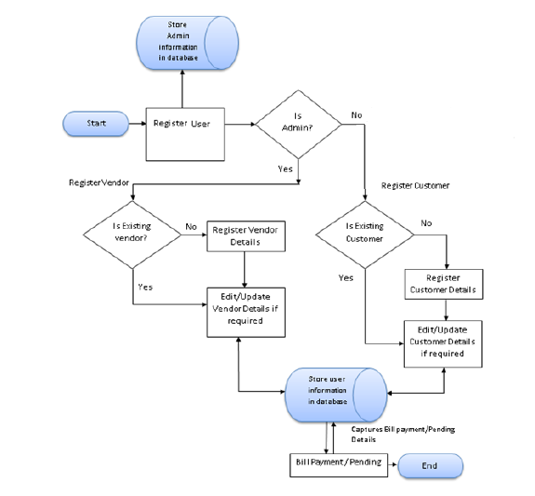

System Design

Proposed design
Considering the anomalies in the existing system computerization of the whole activity is being suggested after initial analysis. The “Bill Payment System” is an online bill payment management system that helps in managing various bill payment operations effectively. This is a web application allows you to access the whole information about bill payment mechanism software, readily scalable and adaptable to meet the complex need of users who needs to pay the bills easily and fast.

Component inventory

Model Components

- Bill.java
- User.java
- Vendor.java
- Role.java

Controller Classes
- UserController.java
- AuthenticationController.java
- BillController.java
- VendorController.java

Service Classes
- AppUserDetailsService.java
- AppVendorDetailsService.java
- AppBillDetailsService.java

Repository Classes
- UserRepository.java
- RoleRepository.java
- BillRepository.java

Security Classes
- JwtAuthorizationFilter.java

5.2.6 Application Classes
- AppUser.java
- AppVendor.java
- SecurityConfig.java
- WebConfig.java

Exception Classes
- UserAlreadyExistsException.java
- VendorAlreadyExistsException.java

UI-Angular Components
- Bill-item-details component
- helppage component
- homepage component
- item-info component
- vendor-item-info component
- payment-gateway component
- item-edit component
- login component
- signup-component
- vendor-signup component
- search-component
- service-component
- Signup-component
- App component
- App.component.html
- App-routing.module.ts
- App.module.ts

Database Design

Data Model

Table Structure
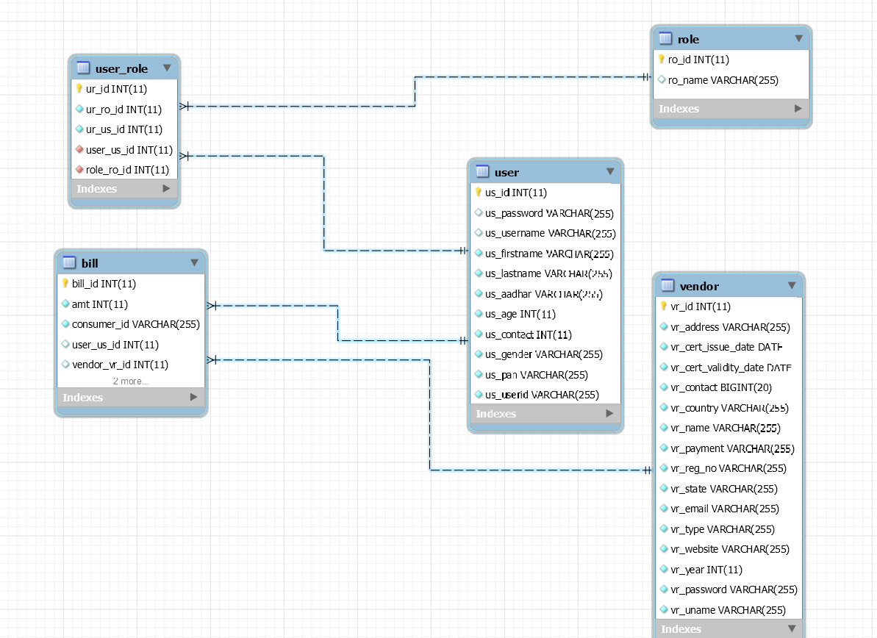

User Registration
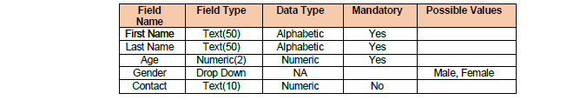
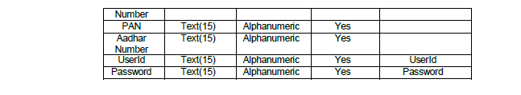

Vendor Registration
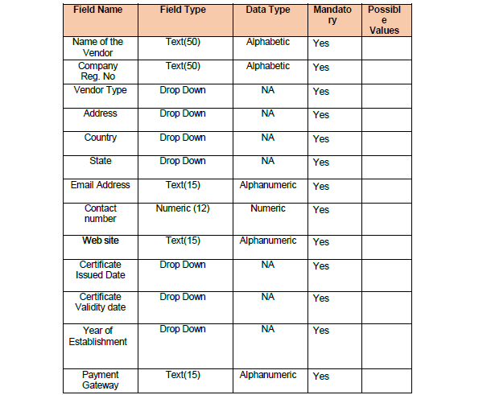

Bills Mapping
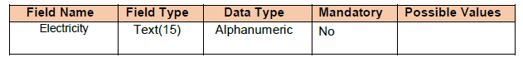
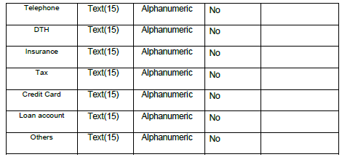

Bill Payment
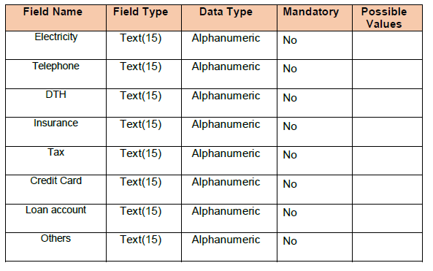

Appendices

Glossary
Acronyms | Definitions
JDBC | Java Database Connectivity
API | Application Programming Interface
JSP | Java Server Pages
DB | Database
Apache tomcat | Apache Tomcat is an open source Web server tool developed by the Apache Software Foundation (ASF). It is one of many Apache-related open source products used by IT professionals for various tasks and objectives.

7.0 Terms And Conditions
Interns shall be solely responsible for all its acts and omissions under this program. Interns will comply at all times with all applicable laws. Interns shall not use Cognizant’s name, logo and trademark in any promotional materials or other communications with third parties without the prior written consent of Cognizant. Any materials used by interns in relation to program will not infringe the copyrights, trademarks, patents, trade secrets or other intellectual property rights, privacy or similar rights of any person or entity. Interns agrees not to post, draw, make, display any content that is threatening, libelous, obscene, defamatory, abusive, pornographic, or advocates/encourages any conduct that could constitute a criminal offence or give rise to any civil liability. Cognizant its associates’ personal details including but not limited to name, address, contact number shall not be shared or forwarded to any third party, without prior written consent of Cognizant, its associates. All intellectual property provided by Cognizant, as part of program shall be owned exclusively by Cognizant. Intern shall indemnify, defend and indemnify Cognizant its associates, officers, directors from and against any claims, demands, loss, damage, liability, causes of action, judgments, or costs and expenses of every nature (including attorney’s fees and expenses) incurred by Cognizant based on any claim that any breach of terms and conditions of this program

Change Log
Please note that this table needs to be maintained even if a Configuration Management tool is used.
Version Number | Changes made
V<n.n> | <If the change details are not explicitly documented in the table below, reference should be provided here>
V<n.n> | Page no | Changed by | Effective date | Changes effected

